NOTES :

Before using the program please test each instruction beforehand so you d be sure every thing works as you intend it to be

User interface :

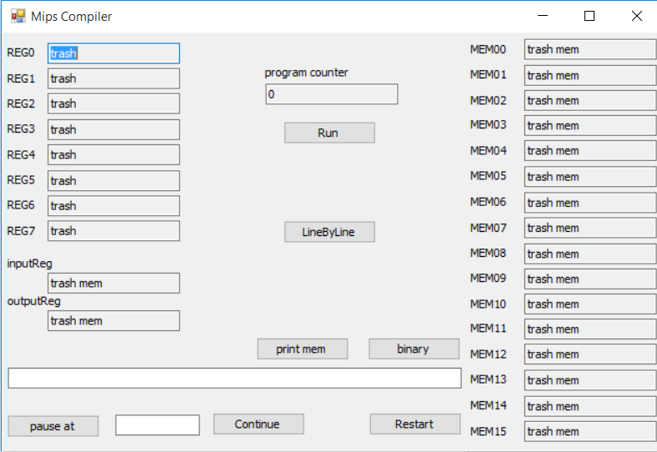

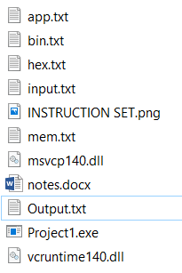

The program reads your application from app.txt

Press restart then run to run the entire program or line by line to ....

Binary prints your code in binary and hex , print memory prints your mem in hex values inside the file mem.txt

Pause at can pause the program when it reaches a certain line

(pause takes more time in execution so be paitent )



Continue continues the program from where u paused

All user interface values are hexdecimal

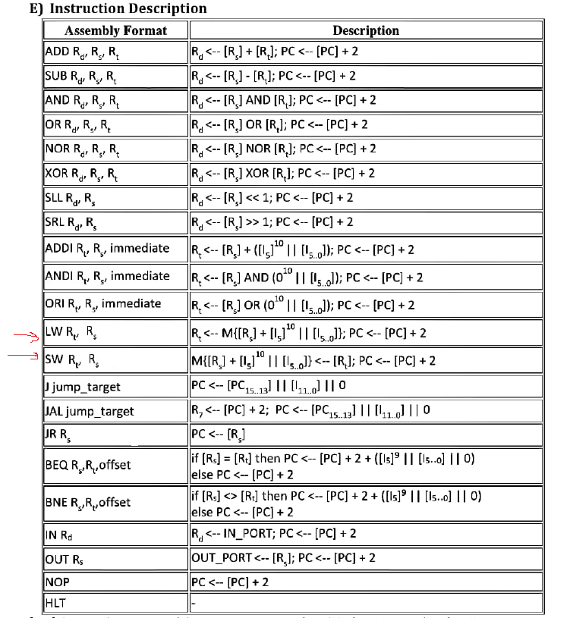

Please note we eraesed the offset in LW and SW

how to write instructions

\*All lines have to be capital and all numbers have to be decimel

Example: ORI R6, R6, 15

\*Maximum value for immidiate numbers inside the instruction is 31 ; its supposed to be 63 but it caused some problems so test it yourself before going over 31

\*imidiate value for 2 is 02 not 2 and zero is 00 and so on , and ofcorse imidiate calue is decimal

\*DO NOT LEAVE UNNECASRY SPACES preferably no spaces at all

Jump :

All labels has to start with a small x not X and end with “:”

Example :

J xnameOfYourLabel < no “:” when using the label

.

.

.

.

xnameOfYourLabel: ORI R6, R6, 15 🡪 do not leave the label without instruction

لو حد عندة jump ف سطر اكبر من 2 اس 12 (حجم الجمب ف الانستراكشنز) الاسيمبلر هيترجمها لرقم غلط ف خلوا بالكم تعدلوها ب ايدكم لو عندك label ف سطر اعلى من 4096

OUT :

Puts a certain regester on the output pins so we saved every out inside the out.txt and all the numbers are in hexa

IN :

Takes input from the input pins so you will have to specify the value each time you need it inside the input.txt file

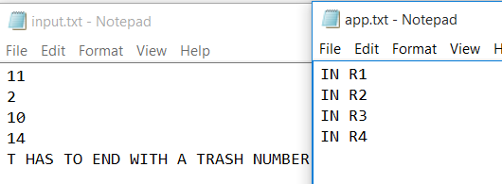

ALL Input are decimal values

\*Memory:

As for memory file it contains only the memories that has a non zero value

Mem has 2^16 adress that is xFFFF as specified in the instruction sheet

If the program crashes that means you made an infinite loop